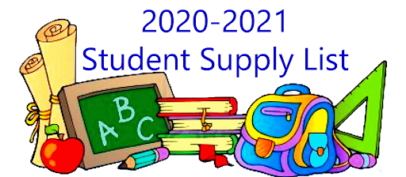

**Ms. Coleman’s Class**

**(4) packs of Loose Leaf Paper**

**(2) packs of 3x5 index cards (neon colors)**

**(6) packs of Dividers**

**(2) boxes of Kleenex Tissue**

**(2) Composition Notebooks**

**Box of Pencils**

**Colored Pencils**

**Glue Sticks**

**Ear Buds**

**Gallon and Quart size- Boxes of Ziploc Bags**

**(3) 5 Subject Notebooks**

**(1) 3 Ring Binder**

**Pre-filled Water bottle**